4- LED
- What is optoelectronics?
Ans. / is a segment of electronics which involves the conversion of optical signals into electrical signals and vice versa. Optoelectronics also entails the coupling of optical and electronic signals.
- What does a Standard light-emitting source include?
Ans. / LEDs in diverse visible colours - IR-LEDs - Laser diodes
- What does Standard light sensitive receivers include?
Ans. / Photoresistors – Photodiodes – Phototransistor – Photothyristor - Solar cells
- Write short notes about LEDs
Ans. / LEDs or light emitting diodes exist in various colors. The most common of these are red, green and yellow LEDs. In recent times blue LEDs have emerged thanks to requirements from the car industry (headlamp control lights). In addition to visible colors there are also LEDs which emit light which is invisible to the human eye, infrared light.

- What is the break voltage of the LED characteristic depends on?
Ans. / The color of the LED.

- Draw a circuit used to measure the break voltage of LED
Ans. / 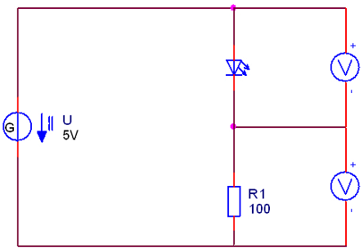
- Measure the threshold voltage and current while using a RED light emitting diode.
U_{S}= ___2____V
I_{S}= ____30___mA

- For the circuit in problem 6, connect the silicon diode into the diode position. Measure the voltage and current and enter these values below.
U_{S}= ____0.7___V
I_{S}= ___43____mA
5- Zener diode
- Draw Conducting and blocking characteristic of a Zener diode.
Ans. /
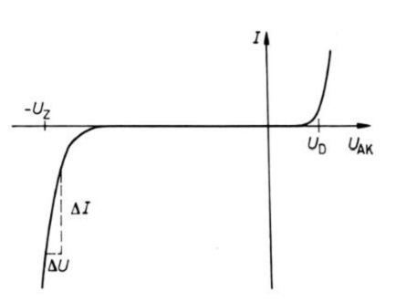
- Write short notes on zener diode and its Functional description
Ans. / Zener diodes also act like a valve for electric current. They allow the current to pass in the forward or conducting direction,from anode to cathode and respond overall like normal silicon diodes here. In the reverse direction they block but only up to a specifically defined voltage, the so-called Zener voltage. When Zener voltage levels are reached the Zener diode conducts through. The Zener voltage is predetermined during the production process. There are various types starting withlow voltages, like e.g. 2.7Vup to ranges exceeding 100 V. Zener diodes are normally operated in the blocking direction.

- Compare between Conducting direction and Blocking properties in zener diodes
Ans. / Conducting direction:
Z-diodes possess a low conducting state voltage of approx. 0.7 V. The conducting state region is not of interest for typical applications.
Blocking properties:
Z-diodes become conductive starting at the Zener voltage. This means they have a low resistance, whose value can be determined from the slope of the blocking characteristic.

- Draw a circuit used to measure the characteristics of 4.7 zener diode
